Christian Clark

CIS 123

CH10 New Screenshots

This is a word doc with the new screenshots from the algorithm workbench/Exercises to show the output easily

1. mWriteAt.asm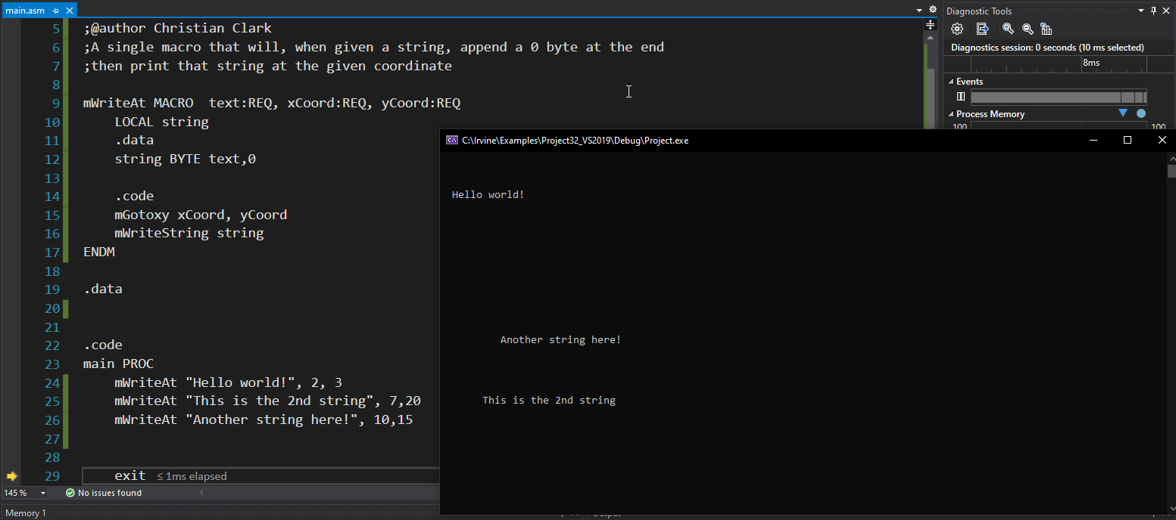

2. This is the expanded code from the listing file, The raw listing file will also be included(Workbench#9.lst) 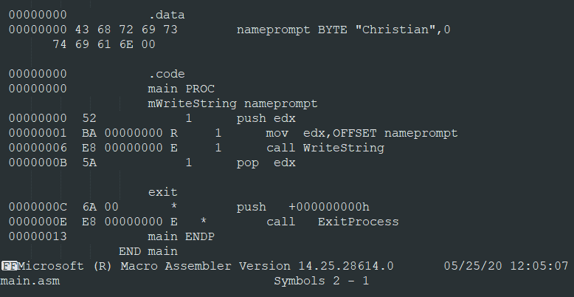

3. mAmpersandTest.asm Tests the & operator with macros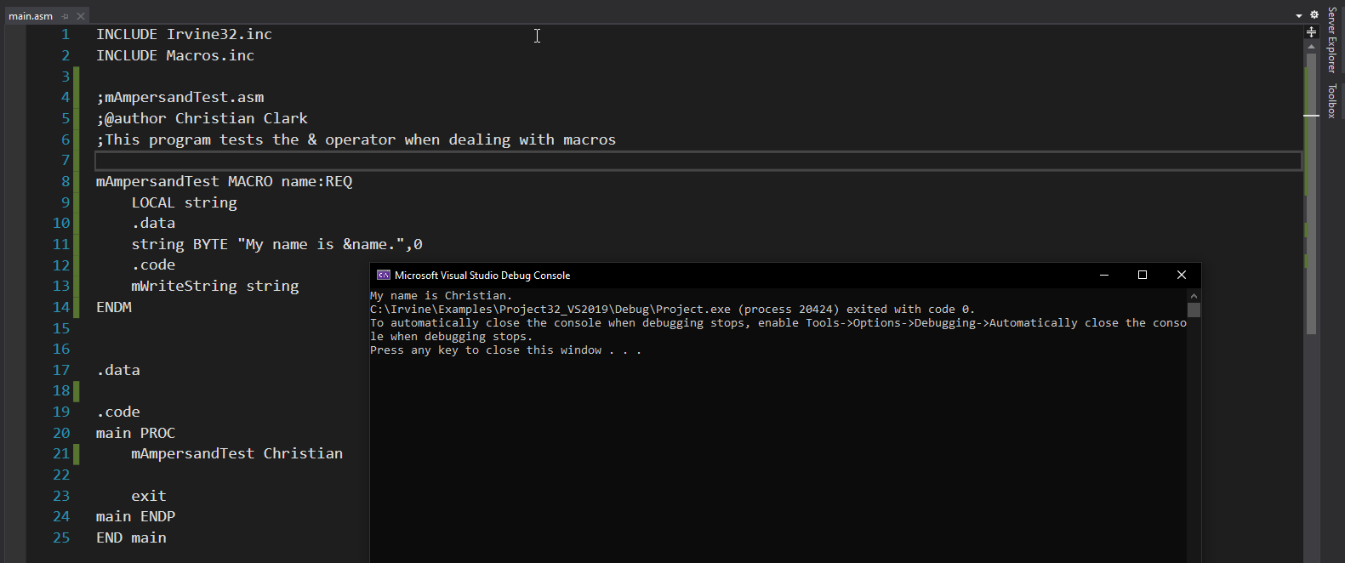

4. Workbench #16 is the listing file named Workbench#16.lst. The program refuses to assemble and I think it is because of the interrupt in the macro not playing well with 32bit mode. What did assemble is in that listing file.

5. mShiftDoublewords.asm (comments and notes are inside the file) 